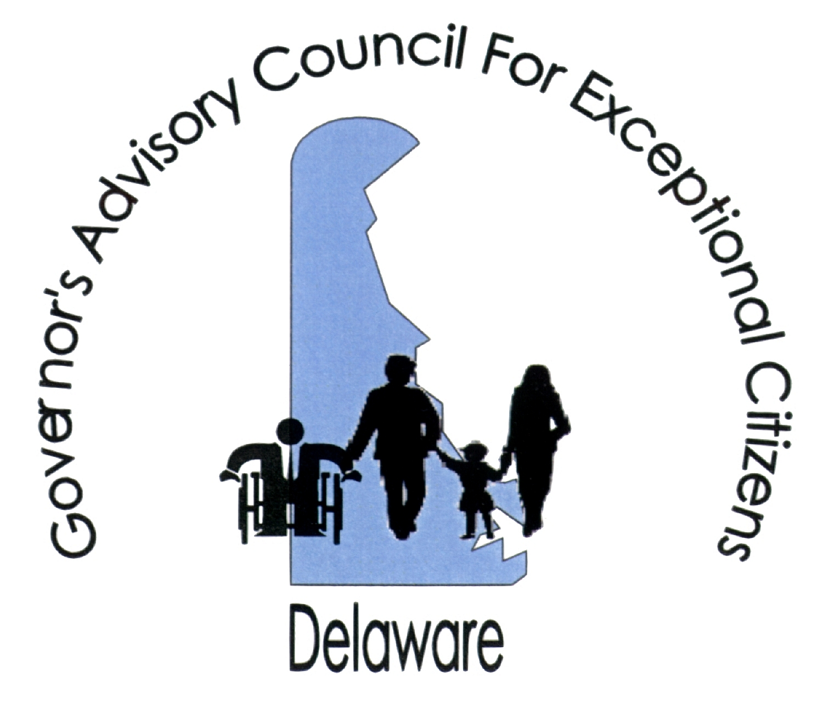

Governor’s Advisory Council for Exceptional Citizens (GACEC)
516 West Loockerman St., Dover, DE 19904
302-739-4553 (voice) 302-739-6126 (fax) http://www.gacec.delaware.gov

MEMORANDUM

DATE: February 26, 2021

TO: The Honorable Members of the Delaware General Assembly

FROM: Ann C. Fisher, Chairperson
GACEC

RE: Senate Bill No. 20 Delaware Equal Accommodations Law (DEAL)

The Governor’s Advisory Council for Exceptional Citizens (GACEC) has reviewed Senate Bill No. 20, which seeks to expand upon and clarify some aspects of parking for persons with disabilities by amending the Delaware Equal Accommodations Law (DEAL) and the Motor Vehicle Code. Council supports the concept of the legislation but would like clarification on the goal of the legislation and the problem it seeks to eliminate.

The amendments to DEAL would make it an unlawful practice for a person (designated as the “owner, lessee, proprietor, manager, director, supervisor, agent, or employee of any place of public accommodation”) to fail to allow individuals with a special license plate or persons with disabilities to park at their respective establishments. The amendments specifically make unlawful signs that prohibit parking by the above-mentioned individuals. The amendments to DEAL dovetail with the amendments to the Motor Vehicle Code (MVC) in terms of defining a person with a special license plate and a person with disabilities. As allowed under 2134 through 2135. The procedures for filing a complaint with the State Human Relations Commission (HRC) and the investigative powers of the HRC and Division of Human Relations and remedies in DEAL for a violation of the conduct proscribed in the amendments would apply.

By making the failure of a person to allow specified parking by a person with a special tag or a person with disabilities unlawful under DEAL, it will bring the conduct under the authority of the State Human Relations Commission (HRC) and the Division of Human Relations. This will allow for the filing of a complaint by the aggrieved party (although the Division of Human Relations can investigate compliance with the statute on its own without a complaint). It will bring into force the investigative powers of the HRC, including the ability to issue subpoenas and order discovery. Upon finding a violation of the statute, the Division of Human Relations can provide relief including damages to the aggrieved party for humiliations and embarrassment, expenses, costs, attorneys’ fees, injunctive or other equitable relief. The division can also assess a civil penalty against the perpetrator to “vindicate the public interest.” 6 Del. C. 4508(h).

The bill also amends the MVC code to allow persons who have a special license plate and persons with disabilities to park in an unmetered parking space for an “unlimited period” of time and in a metered parking space for at least an hour.

This bill appears to give more rights and strengthens the rights of persons with disabilities. However, if the intent of the legislation is to prohibit public accommodations from refusing to provide accessible spaces and allow parking, the sponsors of the legislation may wish to revisit the language to ensure that this intent is clear.

Thank you for your time and consideration of our support. Please feel free to contact me or Wendy Strauss at the GACEC office should you have any questions.

