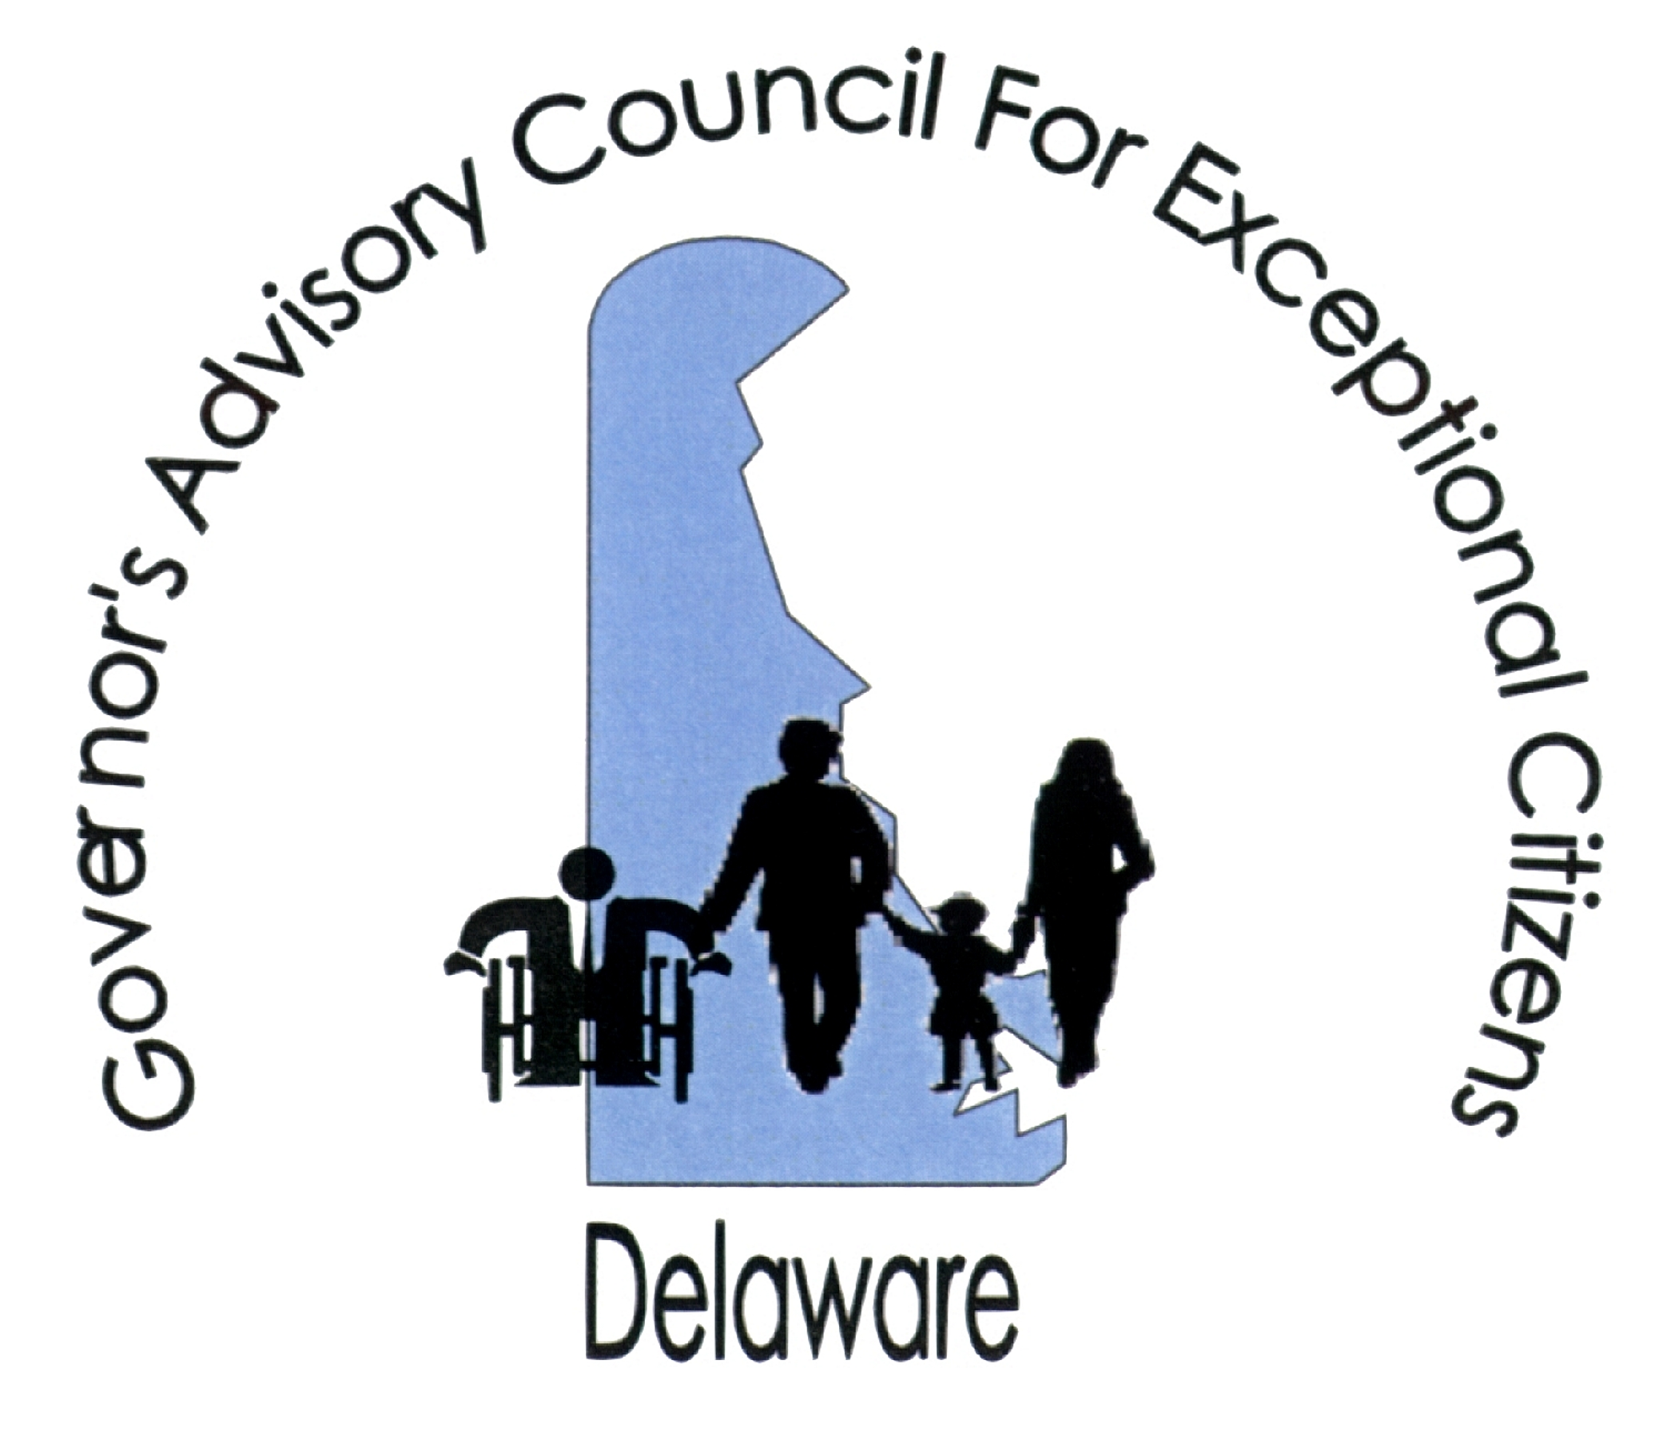

Governor’s Advisory Council for Exceptional Citizens (GACEC)
516 West Loockerman St., Dover, DE 19904
302-739-4553 (voice) 302-739-6126 (fax) http://www.gacec.delaware.gov

MEMORANDUM

DATE: February 26, 2021

TO: The Honorable Members of the Delaware General Assembly

FROM: Ann C. Fisher, Chairperson
GACEC

RE: House Bill No. 62 Prescription Drug Pricing

The Governor’s Advisory Council for Exceptional Citizens (GACEC) has reviewed House Bill No. 62, which is a comprehensive effort to control the prices of generic and off-patent drugs sold, dispensed or delivered to any individual in Delaware and provides stiff penalties for violations. Council endorses the proposed legislation.

The bill requires Pharmacy Benefits Managers and State agencies to monitor the prices of generic and off-patented drugs and notify the manufacturers and the Attorney General of any excessive price increases. The bill also gives power to the Attorney General to gather information and records from the manufacturer to determine whether a violation of the statute has occurred. 6 Del. C. §2599(3). The bill allows the Attorney General to utilize the courts to enforce the provisions of the statute when a violation occurs. 6 Del. C. §2599(4).

The bill defines excessive price increase as an increase, after adjustment for inflation by the consumer price index, that exceeds 15% of the wholesale acquisition cost during the last calendar year or 40% of the wholesale acquisition cost during the last three calendar years. 6 Del. C. §2598(2)b.1. An excessive price increase also occurs when the increase, after adjustment for inflation by the consumer price index, exceeds $30.00 for a 30-day supply of the generic or off-patent drug or for a supply for a course of treatment lasting less than 30 days. 6 Del. C. §2598(2)b.2. However, a wholesale distributor or pharmacy can increase the price of a generic or off-patent drug if the increase is “directly attributable to additional costs for the drug imposed on the wholesale distributor or pharmacy by the manufacturer of the drug.” 6 Del. C. §2598(2)c.

If a manufacturer of generic and off-patent drugs is found by the Attorney General to have imposed an excessive price increase, in violation of the definitions mentioned above, the Attorney General can utilize the courts for a number of remedies. A court can enjoin or stop the violation and order the prices to be lowered to levels that comply with the statute. 6 Del. C. §2599(3)b. The court can require the manufacture to provide the Attorney General with an accounting that shows the revenues received by the manufacturer as a result of the excess price increase. 6 Del. C. §2599(3)c. The court can order restitution of the excess price increase revenues to consumers and third party payers (6 Del. C. §2599(3)d.) or to the State if the manufacturer cannot identify the individual transactions entitled to a refund. 6 Del. C. §2599(3)e. A fine of up to $10,000 per day for each violation can be imposed by the court. (6 Del. C. §2599(3)f.), and every transaction that results in an excess price is considered a separate violation. 6 Del. C. §2599(5). The court can also award attorney’s fees and costs to the Attorney General in prosecuting the action. 6 Del. C. §2599(3)g.

A manufacturer or distributor of a generic or off-patent drug cannot withdraw the drug from sale or distribution in Delaware to avoid the provisions in the statute. 6 Del. C. §2599(6). Any manufacturer who intends to withdraw a generic or off-patent drug from sale or distribution in Delaware must give at least 180-day notice to the Board of Pharmacy and the Attorney General of its intent to do so. 6 Del. C. §2599(7). If the Attorney General determines that the manufacturer withdrew a generic or off-patent drug from distribution or sale, the Attorney General shall impose a penalty of $500,000 on the manufacturer or distributor. 6 Del. C. §2599(8).

This bill reflects the sponsor’s (Representative Andria L. Bennett) concern about the cost of drugs in general and specifically the cost of generic drugs and drugs where the patent protection has expired. Delaware is among the states that are taking action to control the rising cost of prescription drugs. According to the National Academy for State Health Policy (NASHP), as of the end of October of 2018, state legislators introduced 174 bills addressing the cost of prescription drugs and 45 were enacted into law.

Council considers this a laudable effort by the legislature to help control the cost of drugs in Delaware. It will directly benefit individuals with health conditions, especially low-income individuals and those with plans that require the use of generics. As stated earlier, Council endorses the bill.

Thank you for your time and consideration of our endorsement. Please feel free to contact me or Wendy Strauss at the GACEC office should you have any questions.

