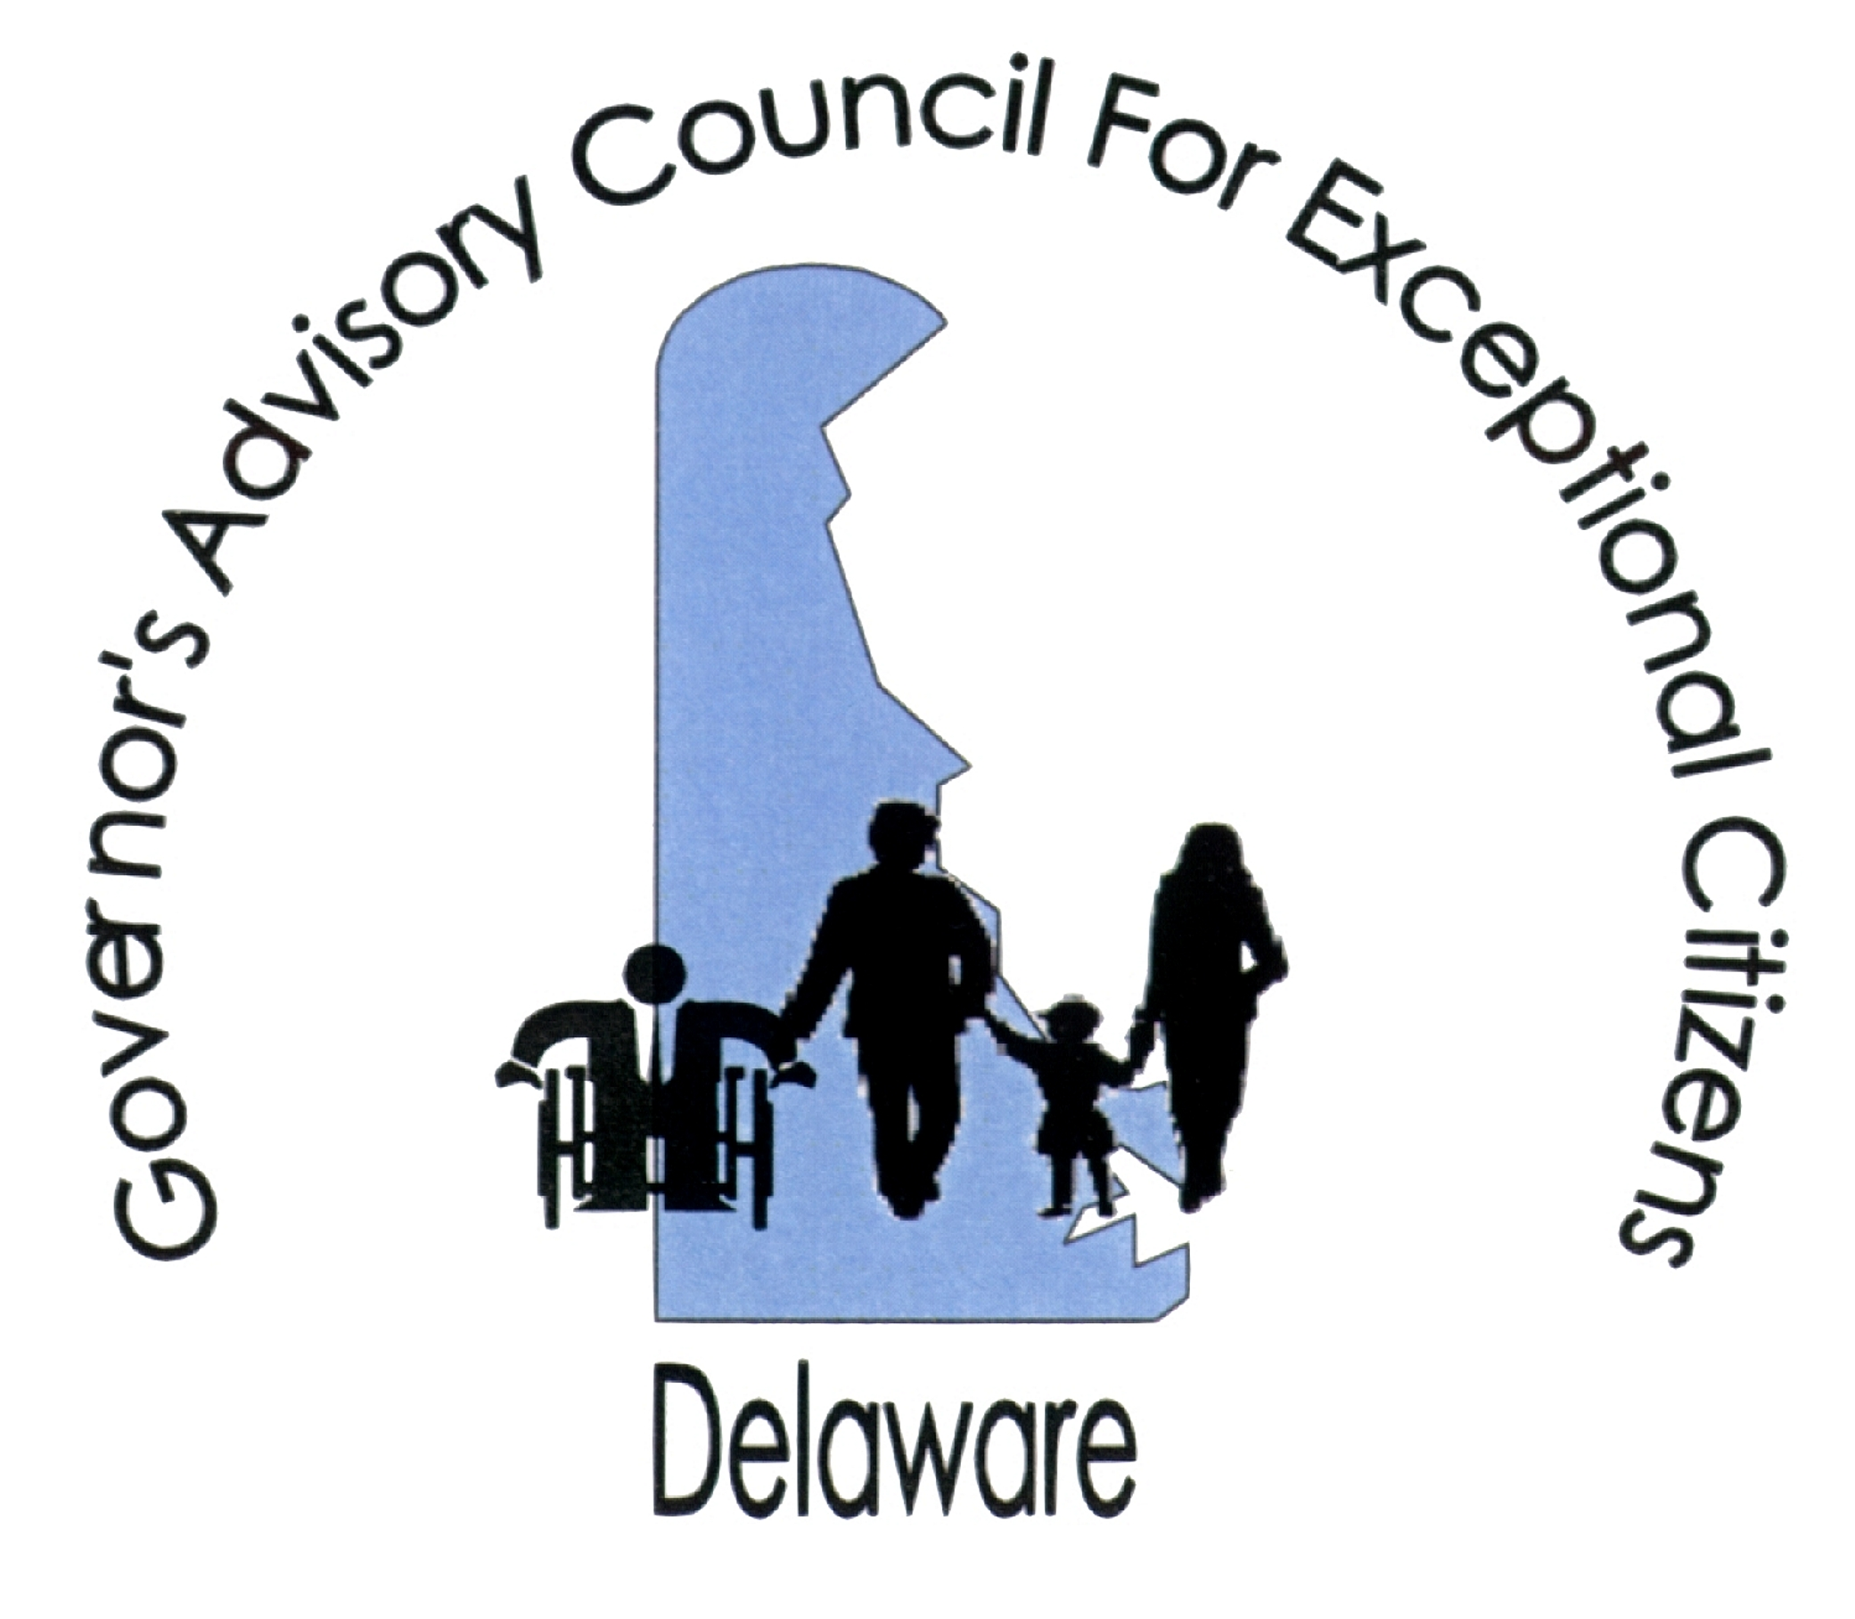
516 West Loockerman St., Dover, DE 19904
302-739-4553 302-739-6126 (fax)
To: All Delaware Schools
From: Governor’s Advisory Council for Exceptional Citizens (GACEC)
Date: September 20, 2017
Re: Disability History and Awareness Month Poster Contest
This year’s theme is the LIFE (Life, Independence, Families, and Education) Conference - Celebrating 20 Years of disability-related information and advocacy
Greetings Teachers and Administrators:
Governor Markell signed House Bill 123 on August 17, 2011, which designated October as Disability History and Awareness Month in Delaware. The bill encourages school districts across Delaware to implement activities to observe Disability History and Awareness Month. A number of districts and charter schools across the State have participated in the past by putting information on their marquees, including information on famous people with disabilities in their morning announcements and newsletters and by inviting individuals with disabilities to share their stories with students. They also had their students develop posters for the statewide poster contest. We are pleased to invite your school district to participate in the annual statewide Disability History and Awareness Month Poster Contest. We hope to have participation from ALL schools this year.
Please read the Poster Specification and Rules carefully. Entry forms may be duplicated. Posters should be mailed to the GACEC (516 West Loockerman St., Dover, DE 19904) and must be postmarked by Friday November 10, 2017. After receiving the entries, the GACEC will select a winning poster for each of the five divisions (elementary, middle school, high school, adapted/assisted art and Computer Aided Art). The winners will be notified no later than November 30, 2017. The students whose posters are selected will be invited to an awards luncheon with Delaware dignitaries.
Your support in this important Disability History and Awareness Month activity is greatly appreciated. Please share this information with all of your faculty and students. We know we have a lot of artistic talent in the State. If you have any questions regarding the poster contest, please contact Kathie Cherry, GACEC Office Manager at (302) 739-4553 or kathie.cherry@gacec.k12.de.us.
Sincerely,
Wendy S. Strauss,
GACEC Executive Director

DISABILITY HISTORY AND AWARENESS MONTH
POSTER CONTEST
Who May Enter:
Any student of a Delaware public, charter or private school may submit a poster.

THE DIVISIONS ARE:
Elementary: Grades K - 5, Middle: Grades 6 - 8, High School: Grades 9-12
Computer Generated Art: Grades 9-12 only at this time
Adapted Art: For students requiring assistance or adaptive technology to participate
Deadline:
Completed poster designs must be postmarked before midnight, Friday November 10, 2017. All entries become the property of the Governor’s Advisory Council for Exceptional Citizens (GACEC) and will not be returned.

Poster Specifications and Contest Rules:
- Completed posters should be at least 8.5 x11 and no larger than 12x18.

- The Disability History and Awareness Month Poster Contest entry blank with information typed or printed clearly should be securely glued to the back of the poster.

- Posters will be judged on originality, clarity of message and quality of artwork. The decision of the judges will be final.

- All posters and slogans must harmonize with the theme of Disability History and Awareness Month.

- Entrants agree to give the GACEC ownership of their artwork with the right to reproduce it.

- Winners will be notified by phone, mail and/or e-mail
POSTER ENTRY FORM

(FINAL SUBMISSION DATE – November 10, 2017)

Please Print

Student Name: Grade:

Division (Circle One) Elementary Middle High Computer art Adapted Art

School Name: ________________________________________________________________

School Address:

Principal’s Name: Teacher’s Name:

Teacher’s E-Mail Address: School Phone:

*I understand that any artwork my child submits becomes the sole property of the GACEC and may be reproduced for publication by the agency.

Parent Signature: _____________________________________________________________

I agree to allow my child’s name to be included if his/her picture is selected for publication
_____ Yes _____ No

POSTER ENTRY FORM

(FINAL SUBMISSION DATE – November 10, 2017)

Please Print

Student Name: Grade:

Division (Circle One) Elementary Middle High Computer art Adapted Art

School Name:__________________________________________________________________

School Address:______________________________________________________________

Principal’s Name: Teacher’s Name:

Teacher’s E-Mail Address: School Phone:

*I understand that any artwork my child submits becomes the sole property of the GACEC and may be reproduced for publication by the agency.

Parent Signature: _____________________________________________________________

I agree to allow my child’s name to be included if his/her picture is selected for publication
_____ Yes _____ No

