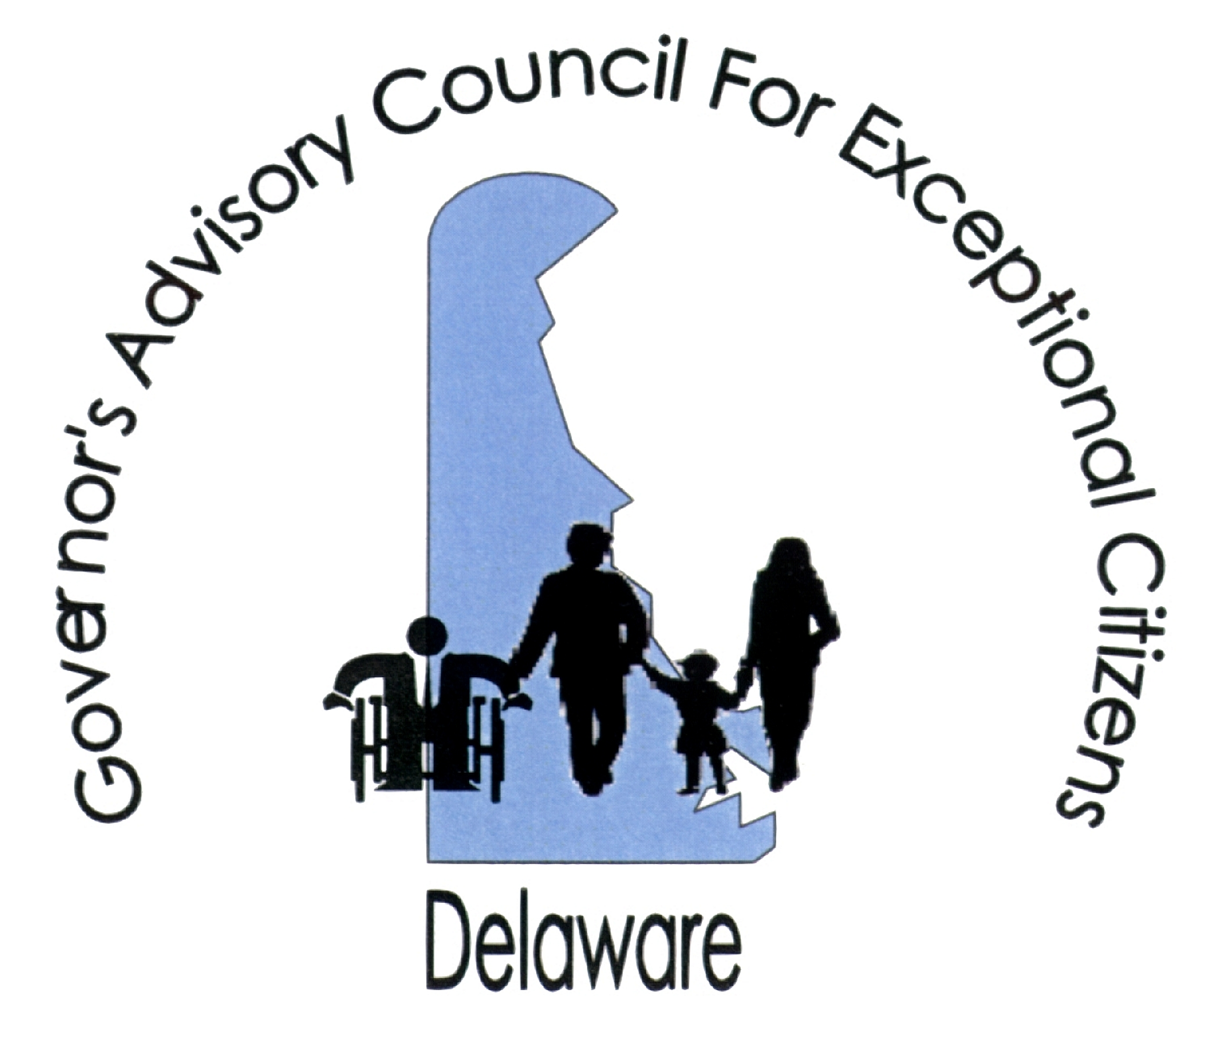

Governor’s Advisory Council for Exceptional Citizens (GACEC)
516 West Loockerman St., Dover, DE 19904
302-739-4553 (voice) 302-739-6126 (fax) http://www.gacec.delaware.gov

MEMORANDUM

DATE: May 25, 2016

TO: The Honorable Members of the Delaware General Assembly

FROM: Robert D. Overmiller, Chairperson
GACEC

RE: Senate Bill No. 230 (Supported Decision-making)

The Governor’s Advisory Council for Exceptional Citizens (GACEC) has reviewed Senate Bill No. 230, which would create the option of a supported decision-making agreement for adults who do not need a guardian but who need assistance in gathering information, making decisions, and communicating those decisions. The GACEC endorses the proposed legislation.

In recent years, the federal Administration on Aging and the Administration for Intellectual and Developmental Disabilities have promoted the availability of supported decision-making options. Their rationale is that both the elderly and individuals with disabilities may benefit from the availability of assistance which is respectful of their autonomy while offering a menu of supports from which they can choose.

Many national organizations are also promoting the availability of supported decision-making for persons with disabilities. For example, the national ARC and American Association on Intellectual and Developmental Disabilities (AIIDD) adopted a position statement in April, 2016, “Autonomy, Decision-Making Supports, and Guardianship”. The national position statement includes the following guidance:

• States should provide systemic access to decision-making supports for all individuals with IDD.

• Each individual...should receive the preparation, opportunities, and decision-making supports to develop as a decision-maker over the course of his or her lifetime. All persons with I/DD can participate in their own affairs with supports, assistance, and guidance from others, such as family and friends. People with I/DD should be aware of and have access to decision-making supports for their preferred alternatives.
• Less restrictive means of decision-making supports (e.g. health-care proxies, advance directives, supported decision-making, powers of attorney, notarized statements, representation agreements, etc.) should be tried and found to be ineffective in ensuring the individual’s decision-making capacity before use of guardianship as an option is considered.

See also Joint ARC and AAIID Position Statement, ‘Self Determination” (2011).

Representatives of the Department of Health & Social Services, Office of the Public Guardian, Disabilities Law Program and multiple State Councils including the GACEC, formed a workgroup to prepare enabling legislation resulting in Senate Bill No. 230. The legislation does not supplant guardianship, powers of attorney, or other options available to help individuals with disability-related limitations. Rather, as illustrated in the attached “Comparison of Decision Making Options in Delaware” chart, it is part of a continuum of tools and resources to facilitate decision-making.

In nutshell, the Department of Health & Social Services will publish a form which a “principal “can execute defining the scope of authorized assistance (lines 88-89 and 163). The “supporter” must also sign the form and agree to abide by its terms (lines 98-102). If authorized, the supporter assists the principal in understanding financial, healthcare, and other information (lines113-114); obtaining information (lines 115-117); making appointments (lines 118-119); and helping organize and keep track of information (lines 120-121).

The bill includes many safeguards:

A. The DHSS form must be used (lines 88-90).

B. The form must be signed in the presence of two witnesses (line 91).

C. The supporter and witnesses must not be disqualified based on potential conflicts of interest (lines 92-95 and 124-131).

D. Supporters are barred from misusing their role or information (lines 132-137).

E. Supporters must protect the confidentiality of information (lines 159-161).

F. The principal can revoke the form agreement at any time (lines 105-106).

The supporter essentially assists and facilitates decision-making and implementation of a principal’s decisions. The supporter is not a substitute decision-maker (lines 12-13). This legislation enhances the scope of assistance available to individuals with disabilities, with appropriate safeguards; therefore, it merits the support and endorsement of the Council.

Thank you for your time and consideration of our endorsement. Please feel free to contact me or Wendy Strauss at the GACEC office if you have any questions.

Attachments

